Perimeter Network Security Coursework

Coursework Submission for MSc ASDF CSN11111/8

Edinburgh Napier University 2023-2024 Trimester 1

Lee Dale

40615561

December 2023

Introduction
The primary goal of this perimeter network security design is for the food dealer to allow external users originating outside the perimeter network to securely access a web server within the companies DMZ (De-militarized zone). This includes protection of the assets within the internal network from insecure access, specifically to preserve confidentiality and integrity of data and availability of assets. The secondary goal is to allow users from the branch office, secure access to assets sitting within the internal network.
To reach the goal of the network design the key component to configure is going to be the Cisco ASA device which will act both as a perimeter firewall, allowing external users to the DMZ zone and a VPN access point allowing branch users to the internal network zone. Both external and branch users will be connected to their own ISP routers and accessing their respective zones over the public internet. A VPN will act as a secure tunnel between the branch office and the HQ internal network.
To achieve a high level of security, each device will be security hardened by restricting access to authenticated and authorized users and by ensuring correct configuration of each device, therefore achieving a closed security stance. Configuration of each device will be with the consideration of network security threats such as MAC address attacks, ARP spoofing and DHCP attacks and all non-essential services with open ports will be closed.
The design below will outline the security policy that implements the goals outlined above.

Design
Device Security Hardening and Device access (AAA)
Unauthorized users will attempt to access our network devices and subsequently gain access to our network. If devices are misconfigured or left in their default state, then the network will be vulnerable to unauthorized access. All devices need to go through a security hardening process to mitigate this. The diagram below from Hacking Exposed, Fifth Edition (2005) shows that the top network vulnerability is inadequate router access control.
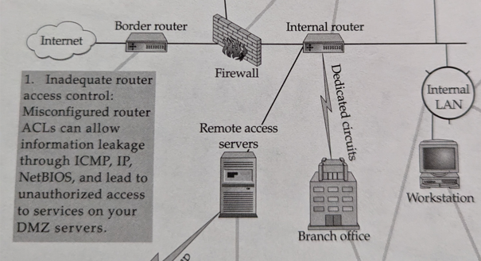
Figure 1 - Copyright 2005 McGraw Hill

HQ and Branch Edge Routers
The HQ and branch edge router acts as the first point of entry from the external internet zone and the networks first line of defense.
Local user accounts are configured for these devices to allow access via console line and over the SSH protocol. This will secure the device to only allow access for configured users. Passwords will be encrypted in the device configuration using Type 8 encryption to avoid the password being leaked should the configuration be accessed by unauthorized users.
Default encryption on Cisco routers is using type 7. As noted in this Cyber security information sheet from the NSA (2022), Type 7 encryption uses a simple Vigenère cipher and can be easily cracked.
We will use Cisco Type 8 encryption as these are hashed using an 80-bit salt and 20,000 iterations for its key derivation function.
The following technical features provide remote access and security hardening for this device.
- Local user accounts are created, and passwords encrypted using Cisco Type 8.
- Console access is enabled using the local user accounts.
- SSH is configured using a domain name and 1024-bit RSA keys.
- Allow SSH access using the local user accounts.

ASA Firewall
The Cisco ASA device will act as the perimeter defense firewall and the endpoint for our site-to-site VPN from the branch office.
User access to the ASA device will be through a central RADIUS server configured on the Net-Admin server located within the internal network. The Net-Admin server will be protected from the external internet zone by the ASA firewall and HQ edge router.
The following technical features provide remote access and security hardening for this device.
- Central RADIUS server configured on Net-Admin server within the internal network zone.
- User accounts are created in the RADIUS user database.
- Console access is enabled using the AAA authentication pointing to the RADIUS server.
- SSH is configured using a domain name and 4096-bit RSA keys.
- Allow SSH access using the AAA authentication point to the RADIUS server.
A login warning banner will also be configured on HQ and branch edge routers and the ASA Firewall devices. These devices act as edge routers and firewalls so this could be the first point of entry for any unauthorized users. A warning banner will make it clear to the user that no unauthorized accessed should be attempted on this device and will cover the company should any legal event arise. A warning banner can be configured using the Message of the Day functionality on the router.

Network security perimeter policy.
Network devices need to be configured with access control lists to make sure network traffic can only access the required portions of the network, and not traverse to parts of the network it shouldn’t be allowed. We can see from Hacking Exposed, Fifth Edition that number eight in the top vulnerabilities is misconfigured ACLs, shown in figure 2.
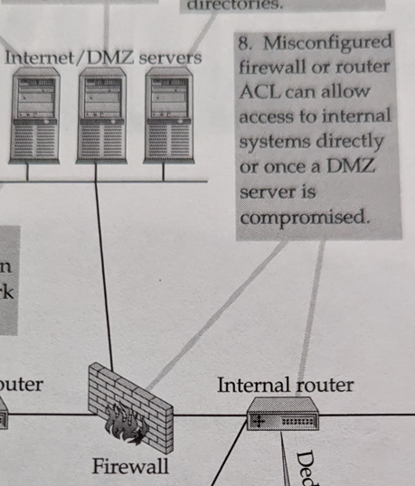
Figure 2 - Copyright 2005, McGraw Hill

HQ Edge Router
The HQ router needs to implement the following network security requirements:
- External -> HQ Internal
- External -> DMZ
The HQ router needs to deny all external traffic entering the HQ internal network unless it has a destination of a device in the DMZ zone (Linux Web Server or DMZ Switch). This means restricting inbound network packets that do not have a destination IP of the 192.168.20.0/24 network.
A named extended ACL called INBOUND-FROM-INTERNET will be created on the HQ edge router and then applied to the e0/0 interface in and the e0/1 interface out. The ACL will have the following rules:
permit tcp any host 192.168.20.7 eq 80
deny any any
ASA Firewall
Security levels in ASA devices work on the principle of not allowing lower security levels to access higher security levels (Networklessons.com 2023).
The security levels are applied to the interfaces on this device. The following security level will apply to the interfaces:
- Gi0/0 = OUTSIDE (Security level 0)
- Gi0/1 = DMZ (Security level 70)
- Gi0/2 = INSIDE (Security level 100)
Cisco Access Control Lists (ACLs) will be used to implement the network security policy on this device. First a named extended ACL called INBOUND-FROM-INTERNET will be created on the device and then applied to the g0/2 interface of the ASA. The ACL will have the following rules:
We need to deny all external traffic entering the internal network unless it is a response to a request originating from the internal zone. This stratifies the policies of not allowing traffic from External and DMZ zones unless in response to a request originating from the internal zone.
In this instance we can apply a deny rule to the g0/2 outbound interface for all IP traffic. As the ASA is a stateful firewall it will allow inbound traffic from the OUTSIDE G0/0 interface and the DMZ G0/1 interface to the INSIDE G0/2 interface only in response to a request originating from the INSIDE G0/2 interface.
deny any any
Logging to a central server
Devices should be configured to log to a central server in the network so that admins will have a central place to view all device logs. SIEM tools can use these central logs for analysis and detection of unusual network activity. These logs can also be used as input to machine learning models for intrusion prevention systems to learn about the normal network traffic.
A syslog server will be configured on the Net-Admin device and all network devices configured to send logs to this server.
Intrusion Detection (IDS)
An intrusion detection system (IDS) is setup on the HQ and Branch routers to look for any malicious traffic that may enter the network via the edge routers. The edge routers are the first point of entry to their respective networks and so it makes sense to attempt to detect any network intrusions at this point.
Site to Site VPN
A site-to-site VPN is configured from the branch office to the ASA Firewall, allowing devices in the branch office network to securely access the FTP server in the internal network.
IPSec will be used to secure the connection and a ISAKMP policy will be created to allow the branch router and ASA firewall to establish security associations and cryptographic keys (Wikipedia 2023). IKE will be used to preserve confidentiality and integrity of the tunneled connection while authenticating each device. IKE parameters will be configured on both the ASA firewall and the branch edge router.
IPSec will be configured in tunnel mode using ESP to encrypt and encapsulate the layer 3 header information (IBM 2021).
Mitigation of network attacks
Protection from network layer 2 attacks such as ARP spoofing and DHCP starvation should be considered in the network design.
To prevent ARP spoofing Dynamic ARP Inspection (DAI) (Cisco. 2007) will be configured on both the VPN-SW Switch and the Per-SW2 switch.
To mitigate against DHCP starvation attacks the DHCP Snooping feature will be enabled on both switches and rate limiting configured.

Prototype Implementation
The features of the network security design outlined above are implemented on each network device to achieve the outcome of the network security policy and to make sure a robust security posture is maintained.
- Initial Network Configuration
HQ Edge Router
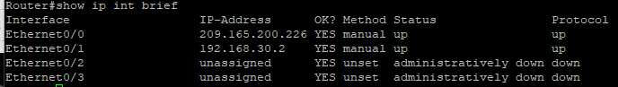
Branch Edge Router
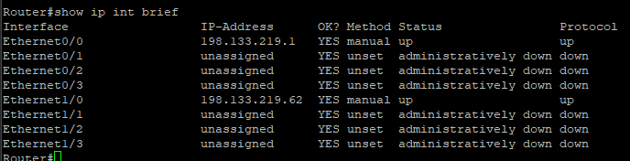
ASA Firewall
Interfaces on the firewall are configured as follows.
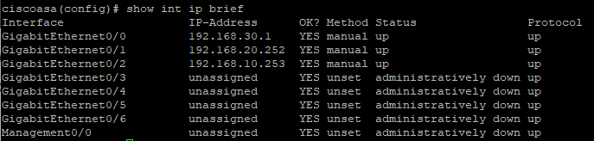
A gateway of last resort also needs to be configured on the firewall to allow access to addresses outside the network.
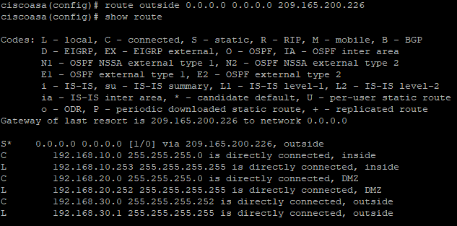
Network Address Translation (NAT) is configured on the ASA Firewall to allow inside network addresses to access outside networks.
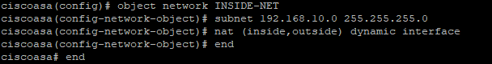
NAT is also configured to allow external addresses to the DMZ zone.
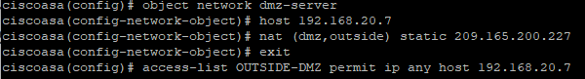
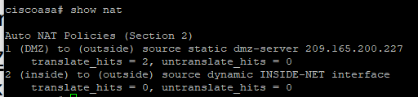
Linux-Web-Server
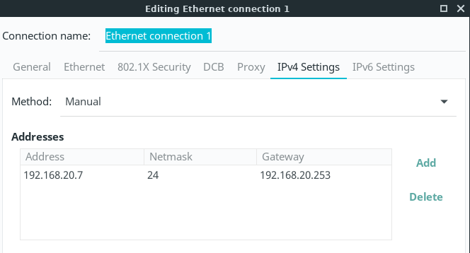
- Device Security Hardening
HQ Edge Router
- Enable SHA256 for the Type 8 encryption and set a secret password:

- Create a local user account with a type 8 password:
Example of encrypted type 8 password in running configuration:
Implementation of a login warning banner using the message of the day functionality:
Banner motd configured in the device running configuration:
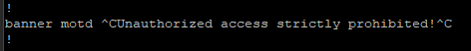
Branch Edge Router
- Enable SHA256 for the Type 8 encryption and set a secret password:

- Create a local user account with a type 8 password:
Example of encrypted type 8 password in running configuration:
Implementation of a login warning banner using the message of the day functionality:
Banner motd configured in the device running configuration:
ASA Firewall
- Enable SHA256 for the Type 8 encryption and set a secret password:

- Create a local user account with a type 8 password:

Example of encrypted type 8 password in running configuration:
- Device access (Authentication & Authorization)
HQ Edge Router
Configuration of console line to use the local account configured above:
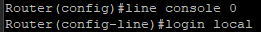
Device is configured to use local accounts for the console line in the running configuration:
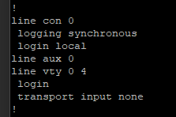
Branch Edge Router
Configuration of console line to use the local account configured above:
Device is configured to use local accounts for the console line in the running configuration:
ASA Firewall
A central RADIUS server is configured on the Net-Admin device inside the internal network using the WinRadius software.
A new user is added inside the WinRadius software:
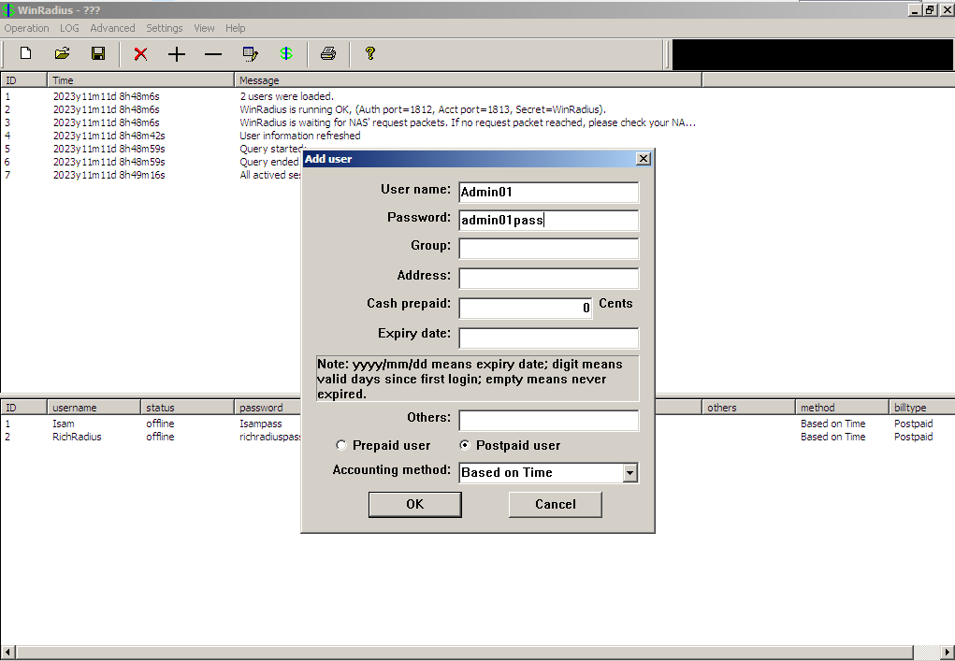

AAA is enabled on the ASA Firewall and a RADIUS server group called central-server is configured on the ASA. The host is set to the IP address of Net-Admin server and the authentication port and key are set.
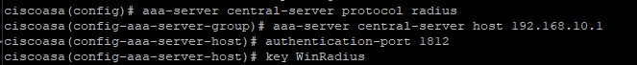
SSH is configured for the ASA Firewall
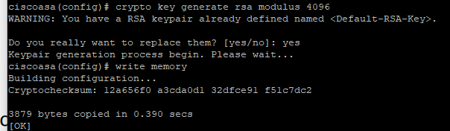
Key length is crucial for a secure device as RSA keys that are too short can be brute forced so we opt ofr a 4096 length modulus.
SSH access is configured for the inside network on 192.168.10.0 255.255.255.0
SSH is enabled for console access.
Running configuration for the ASA Firewall
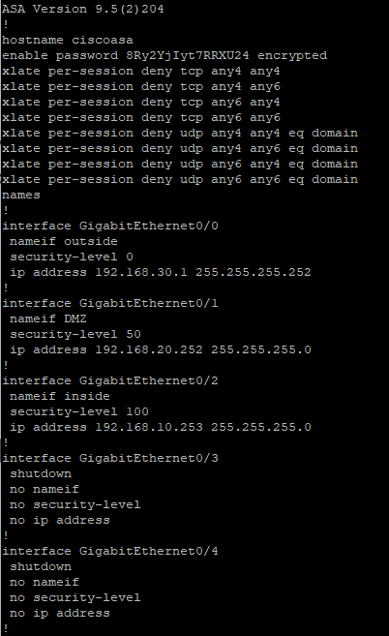
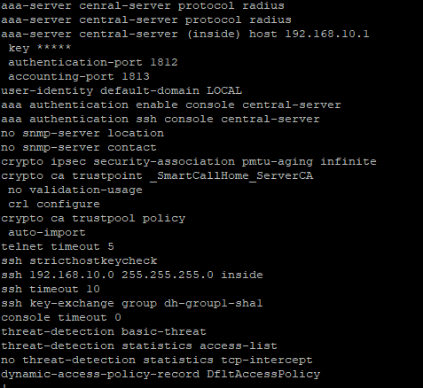
- Network Security Profile
HQ Edge Router
Configuration of network security policy on HQ Edge Router to allow traffic from the external to the web service in the DMZ network.
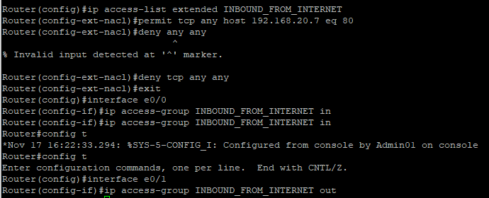
ASA Firewall
We need to allow access from any host (External or internal) to the DMZ.

- Site to site VPN
Branch Router
We configure the IKE parameters by enabling ISAKMP and setting the policy number:
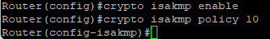
We configure the ISAKMP parameters by setting the authentication method to use a pre-shared key and the encryption to use 3DES
We then set the Hash algorithm to be SHA
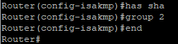
Verification of the ISAKMP policy:
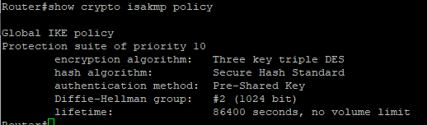
We then configure the ESP tunnel mode parameters:
We then define interesting traffic using an extended ACL. This tells the router which traffic to encrypt when routing traffic.
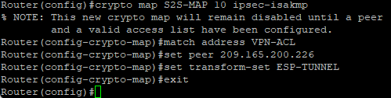
We now need to create a crypto map and apply it to the e0/0 interface on the router.

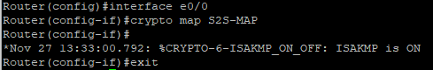
We can see ISAKMP is now turned on for the interface.
- Layer 2 mitigation

Dynamic ARP inspection is enabled on the switches:
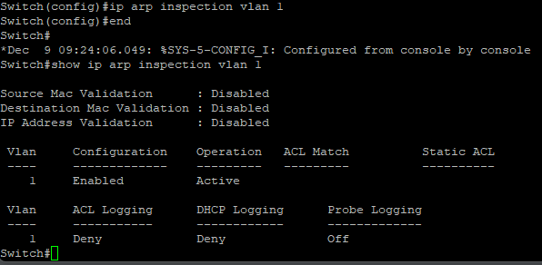
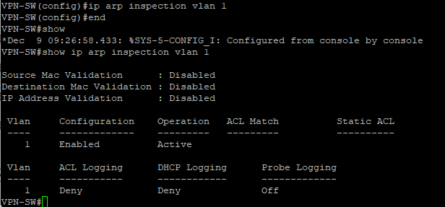
DHCP Snooping and rate limited is enabled on the switches:
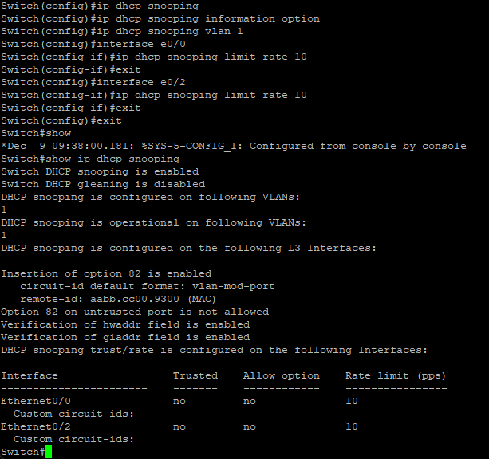
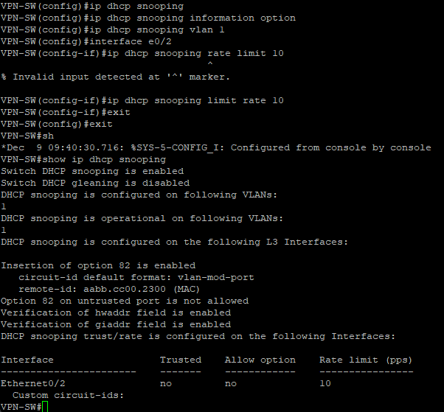

Testing

- Testing Security Profile
The following tests prove the implementation of the network security profile is effective.
- External -> DMZ
Using the HQ router we can test a connection to the Linux Web server over port 80

Capturing packets on the ASA Firewall we can see packets from the HQ router to the Linux web server:

- DMZ -> HQ Internal
By capturing packets on the ASA firewall we can show our ACL policy denying ICMP packets from host in the DMZ zone to a host in the HQ internal zone.

- Testing Authentication and Authorization
HQ and Branch Routers
The following tests console line and SSH access to the HQ and branch routers using a user from the local database.
Testing login to HQ router using local user account and privileged access restriction to the configured secret. Tests also shows the banner warning on connection to the device.
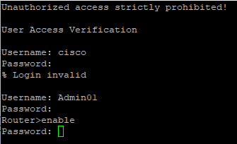
ASA Firewall
The following tests the connectivity from the Cisco ASA firewall device to the Net-Admin server hosting WinRadius and shows that a user configured in the WinRadius database can access the Cisco ASA device using Console line and SSH.
An authentication test is made for the configured username and password from ASA Firewall to WinRadius server.
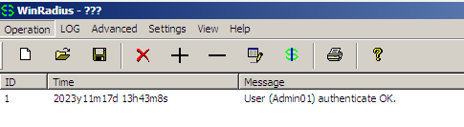
As a test for SSH connectivity console access we use PuTTY on the Net-Admin server to connect over port 22 to the ASA Firewall. A successful connection is made with the username and password configured.
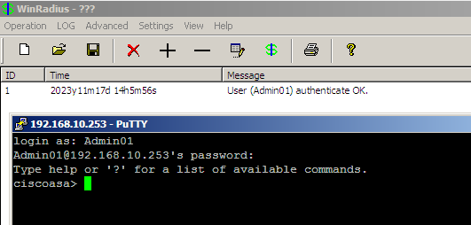

Discussion/Evaluation
For AAA on the ASA Firewall device RADIUS was used as the protocol for authentication. TACACS+ protocol could have been used instead of RADIUS as TACACS+ is supported on the Cisco devices in our network. TASCAS+ would have provided more security because it encrypts the password by encrypting the whole network packet (IEEE 1999). Local authentication was configured for the HQ and branch routers, but this negates the benefit of using a central authentication server. Instead, we can configure the branch and HQ routers to use the central RADIUS server alongside the ASA device so that we have a central place to manage all users that can access and configure the network devices.
In the current network design intrusion detection (IDS) was added to the HQ and branch router. This design could be improved by utilizing the concept of defense in depth and also including a host-based intrusion detection system (HIDS) on each of the client machines namely Net-Admin, Internal PC, Linux-Web-Server and Branch-Admin_Linux devices (Ying L. 2010). We could also implement an intrusion prevention system on the HQ and Branch routers that will actively protect the network by blocking any malicious traffic. In contrast to IDS systems IDPS systems sit in line of the network devices and monitor for anomalous traffic. This would provide more protection to the network by actively blocking any traffic it deems as a possible attack. IDPS system can utilize a machine learning model which has been trained on normal network traffic then potentially block any traffic that it detects as “not normal”. This is further details in the research section.
AN IPSec based VPN was used to connect the branch and HQ networks. IPSec based site to site VPNs was the best VPN technology to use here as it allows users to access multiple services in the HQ network, however only FTP services were needed in this scenario. An SSL based VPN could also have been configured to access the HQ network to allow client machines outside the HQ and branch networks to access services inside the network such as the FTP server. This enables scenarios such as remote working for employees.

Research
The last decade has shown a large increase in the sophistication of network attacks with T. AlMasri, M et al. (2022) mentioning that 10% of all network attacks today are denial of service attacks. Attackers are increasing their sophistication around DoS attacks to circumvent network security measures. Considering this knowledge, it would greatly improve the security of networks if network devices were able to detect and automatically prevent these attacks with great accuracy.
Intrusion detection and prevention systems that use a deep learning approach can be more effective than traditional IDS/IDPS systems at detecting DoS attacks. In their paper on the use of deep learning models in detecting SSH and DDoS attacks, T. -H. Lee. et al. (2020) showed that they could achieve an accuracy of almost 99% in preventing such attacks. Such high accuracy looks promising in dealing with DoS attacks.
There is a problem however with this approach, in that typically the deep neural networks employed for achieving such high accuracy have an issue with latency. The time complexity in analyzing the deep neural network (DNN) increases the latency of the network traffic classification. Classification is needed to first determine if the network traffic is malicious or not. Mission critical IDS/IDPS systems require low latency for classification to be useful in detecting and preventing attacks, while also maintaining network performance.
Illy, P., & Kaddoum, G. (2023). In their paper on collaborative DNN-based low-latency IDPS propose a way to break the intrusion detection into two parts, first using a lightweight DNN to classify an attack with low latency and then a second model to identify the type of attack.
This type of DNN based IDPS could be implemented in our network and placed between the edge routers and the ASA Firewall to achieve high accuracy in detecting and preventing attacks reaching the ASA device and deeper into the internal network or branch office network. This would greatly increase the networks overall resilience to all attacks included in the DNN.

Conclusions
A network design was created that attempts to fulfill the security policies of the network. Security policies were implemented with simple ACLs rules on the HQ and ASA devices. These policies could benefit from more testing to ensure all scenarios of the security policy are implemented.
Basic hardening was implemented on all devices including making sure that only authorized and authenticated users are allowed to access the network devices. A banner was added to edge devices to cover the company in case of unauthorized access. Strong encryption of secrets inside the configuration on each device was utilized by using type 8 Cisco encryption to protect from attackers gaining password information should a configuration file be accessed. Testing of the hardening was carried out by attempting to access each device and proving that only authenticated users could access them.
A central authentication server was configured inside the HQ network and the ASA device was configured to use this central authentication server to authenticate access to the device. This allows central management of users and network device access. However, we identified that this was not configured on the branch and HQ routers which would be a benefit in the future.
A site-to-site VPN is configured to allow services from the HQ network to be accessed by users in the branch network. IPsec is used to create a secure tunnel between the two networks to ensure secure access to an FTP server in the HQ network.
Layer 2 attack mitigation was put in place within the network design. The first mitigation was protection against ARP spoofing in the form on enabling Dynamic ARP Inspection on both the switches in the network. The next mitigation was to use the DHCP snooping and rate limiting features of Cisco switches to protect against DHCP starvation attacks.
Lastly, we considered the current literature on using Deep Learning driven approaches to intrusion detection and prevention. We concluded that such advances in detection of DoS and other attacks could be included in our network design to achieve greater security.

References/Presentation

NSA. 2022. https://media.defense.gov/2022/Feb/17/2002940795/-1/-1/1/CSI_CISCO_PASSWORD_TYPES_BEST_PRACTICES_20220217.PDF
McClure S. et al, 2005. Hacking Exposed (Fifth Edition), McGraw Hill
IBM. 2021. IBM Docs https://www.ibm.com/docs/en/zos/2.3.0?topic=ipsec-ah-esp-protocols
Wikipedia. 2023. Internet Security Association and Key Management Protocol. https://en.wikipedia.org/wiki/Internet_Security_Association_and_Key_Management_Protocol
Networklessons.com. 2023. Cisco ASA Security Levels. https://networklessons.com/cisco/asa-firewall/cisco-asa-security-levels
IEEE. 1999. AAA PROTOCOLS: Authentication, Authorization, and Accounting for the Internet. https://www.scss.tcd.ie/hitesh.tewari/bib_files/met99.pdf
Ou, Y. J., Lin, Y., & Zhang, Y. (2010, April). The design and implementation of host-based intrusion detection system. In 2010 third international symposium on intelligent information technology and security informatics (pp. 595-598). IEEE.
T. -H. Lee, L. -H. Chang and C. -W. Syu, "Deep Learning Enabled Intrusion Detection and Prevention System over SDN Networks," 2020 IEEE International Conference on Communications Workshops (ICC Workshops), Dublin, Ireland, 2020, pp. 1-6, doi: 10.1109/ICCWorkshops49005.2020.9145085.
Illy, P., & Kaddoum, G. (2023). A collaborative DNN-based low-latency IDPS for mission-critical smart factory networks. IEEE Access.
Cisco. (2007). Understanding and Configuring Dynamic ARP Inspection https://www.cisco.com/c/en/us/td/docs/switches/lan/catalyst4500/12-2/25ew/configuration/guide/conf/dynarp.html
T. AlMasri, M. A. Snober and Q. A. Al-Haija, "IDPS-SDN-ML: An Intrusion Detection and Prevention System Using Software-Defined Networks and Machine Learning," 2022 1st International Conference on Smart Technology, Applied Informatics, and Engineering (APICS), Surakarta, Indonesia, 2022, pp. 133-137, doi: 10.1109/APICS56469.2022.9918804.

